MODULE: 1 (SDLC)

1. What is software? What is software engineering?

* **Software:**
* Software is a set of programs, which is designed to perform a well-defined function.
* Software consists of lines of code written by computer programmers.
* **Software Engineering:**
* Software engineering is a branch in computer science that deals with developing applications.
* It covers the technical part of building software systems through designing, implementing, and modifying software
* It also covers software management issues, such as directing programming teams, scheduling, and budgeting.
* Software engineering may be defined as the systematic design and development of software products and the management of the software process.

1. Explain types of software.

* **System Software:**

System software serves as the foundation for application software. It manages hardware and provides basic services for other software. Examples include:

* **Operating Systems**: Windows, macOS, Linux, Android
* **Device Drivers**: Enable the operating system to communicate with hardware devices like printers, graphic cards, etc.
* **Utility Programs**: Perform maintenance tasks such as antivirus software, disk clean up tools, and backup software.
* **Application Software:**

Application software helps users perform specific tasks. It includes a wide range of programs, from business software to media players. Examples include:

* **Productivity Software**: Microsoft Office Suite (Word, Excel, PowerPoint)
* **Web Browsers**: Google Chrome, Mozilla Firefox, Safari
* **Media Players**: VLC Media Player, Windows Media Player
* **Graphic Design Software**: Adobe Photoshop, CorelDraw
* **Communication Software**: Slack, Skype, Zoom

1. What is SDLC? Explain each phase of SDLC.

* The basic activities or phases to be performed for developing a software system are:

1. Preliminary Investigation
2. Feasibility study
3. Requirement Analysis
4. Design of system
5. Development (coding) of software
6. System Testing
7. System maintenance and evaluation

* Preliminary Investigation:
* The first step in the system development life cycle is the preliminary investigation to determine the feasibility of the system. The purpose of the preliminary investigation is to evaluate project requests. It is the collecting of information that helps committee members to evaluate the merits of the project request and make an informed judgement about the feasibility of the proposed project.
* Feasibility study:
* **Feasibility***in*SoftwareEngineeringis a study to evaluate feasibility of proposedproject *or system.* Feasibilitystudy is one of stage among important four stages ofSoftwareProjectManagement *Process. As name suggests* feasibility study is the feasibility analysis or it is a measure of the software product in terms of how much beneficial product development will be for the organization in a practical point of view. Feasibility study is carried out based on many purposes to analyse whether software product will be right in terms of development, implementation, contribution of project to the organization etc.
* *Requirement Analysis:*
* Software requirement means requirement that is needed by software to increase quality of software product. These requirements are generally a type of expectation of user from software product that is important and need to be fulfilled by software. Analysis means to examine something in an organized and specific manner to know complete details about it.
* Therefore, **Software requirement analysis** simply means complete study, analysing, describing software requirements so that requirements that are genuine and needed can be fulfilled to solve problem.
* Design of System:
* Systems Design is the process of defining the architecture, components, modules, interfaces, and data for a system to satisfy specified requirements. It involves translating user requirements into a detailed blueprint that guides the implementation phase. The goal is to create a well-organized and efficient structure that meets the intended purpose while considering factors like scalability, maintainability, and performance.
* Development (coding) of software:
* The coding is the process of transforming the design of a system into a computer language format. This coding phase of software development is concerned with software translating design specification into the source code. It is necessary to write source code & internal documentation so that conformance of the code to its specification can be easily verified.
* Coding is done by the coder or programmers who are independent people than the designer. The goal is not to reduce the effort and cost of the coding phase, but to cut to the cost of a later stage. The cost of testing and maintenance can be significantly reduced with efficient coding.
* System Testing:
* Testing is the major quality control measure used during software development. Its basic function is to detect errors in the software. This phase is used to check whether the any error occurs or not during the execution. Before actually implementing the new system into operation, a test run of the system is done for removing the bugs, if any.
* Using the test data following test run are carried out:
* Program Test
* System Test
* Program test: When the programs have been coded, compiled and brought to working conditions, they must be individually tested with the prepared test data. Any undesirable happening must be noted and debugged (error corrections)
* System Test: After carrying out the program test for each of the programs of the system and errors removed, then system test is done. At this stage the test is done on actual data. The complete system is executed on the actual data. At each stage of the execution, the results or output of the system is analysed. During the result analysis, it may be found that the outputs are not matching the expected output of the system. In such case, the errors in the particular programs are identified and are fixed and further tested for the expected output.
* System maintenance and evaluation:
* Maintenance includes all the activity after the installation of software that is performed to keep the system operational. As we have mentioned earlier, software often has design faults. The two major forms of maintenance activities are adaptive maintenance and corrective maintenance. For large system, removing all the faults before delivery is extremely difficult and faults will be discovered long after the system is installed. After delivering the system to customer, developer also needs to provide the latest update regarding to that system frequently.

1. What is DFD? Create a DFD diagram on Flipkart.

* Data Flow Diagram (DFD) represents the flow of data within information systems. Data Flow Diagrams (DFD) provide a graphical representation of the data flow of a system that can be understood by both technical and non-technical users. The models enable software engineers, customers, and users to work together effectively during the analysis and specification of requirements.

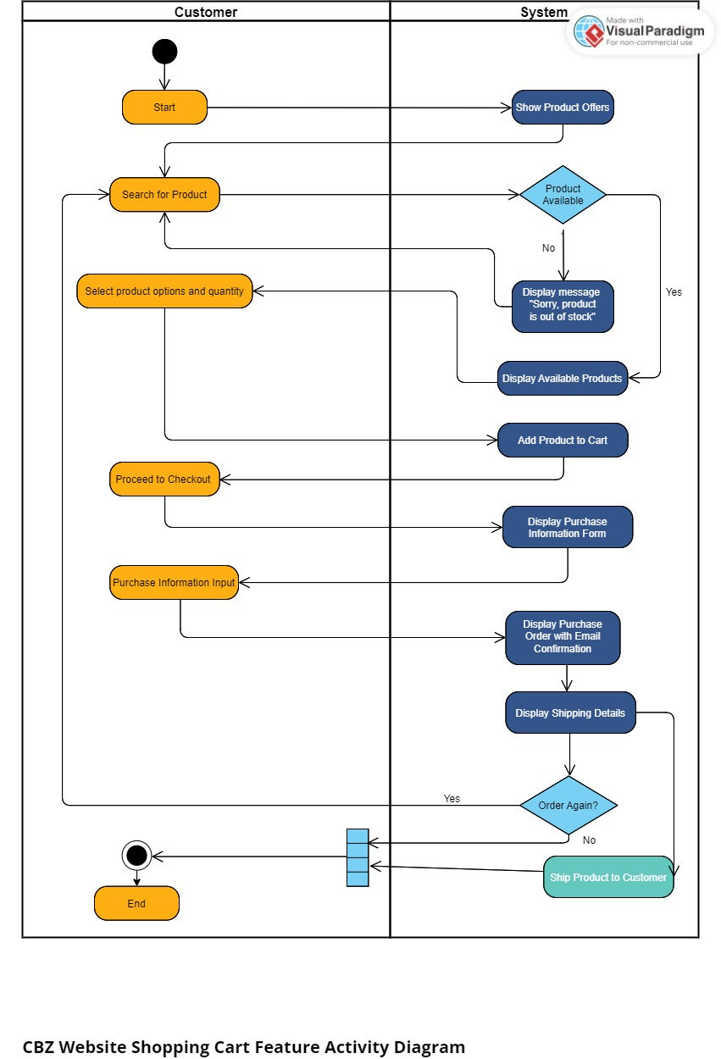

1. What is Flow chart? Create a flowchart to make addition of two numbers.

* A flowchart is a graphical representation of a process or algorithm, showing the steps involved as boxes of various kinds, and their order by connecting them with arrows. It's a useful tool for visualizing the flow of a process or the steps in a task, making it easier to understand and communicate.

End

Display sum

Sum= no1 + no2

Enter no1,

No2

Start

1. What is Use case Diagram? Create a use-case on bill payment on paytm.

* Use case diagram represents the overall scenario of the system. The scenario is nothing but a sequence of steps describing an interaction between a user and a system.
* While developing software, it is essential for the development team to consider user satisfaction as a top priority to make the software successful. For this, the development team needs to understand how users will interact with the system.